273/1
Geography
Paper 1
2 ½ hours

RESOURCEFULMOCKS 2019
UGANDA CERTIFICATE OF EDUCATION
Uganda Certificate of Education
GEOGRAPHY
PAPER 1
2 Hours 30 Minutes

Instructions to Candidates
This paper consists of parts I and II
Part I and section A of part II are compulsory
Answer only one question from section B of part II
Answers to all questions must be written in the answer sheets provided
Any additional question(s) answered will not be marked

PART I
OBJECTIVE – TYPE QUESTIONS (30 MARKS)
There are 30 compulsory questions. Each question carries one mark.
- Population distribution in the Miombo woodlands has mainly been influenced by
- insecurity
- unreliable rainfall
- pests and diseases
- remoteness of the area
- The major problem facing cottage industries in East Africa is
- inadequate capital
- rural – urban migration
- inadequate power supply
- limited market
- A Campbell stokes recorder at a weather station is used to record the amount of
- pressure
- temperature
- sunshine
- humidity
- Which of the following features along the shores of Lake Victoria are a result of wave erosion
- Cliffs and Stacks
- Beaches and Arches
- Stumps and Estuaries
- Caves and Spits
- Cross border trade among the East African countries is mainly limited by ;
- high taxes
- production similar goods
- political instability
- poor transport network

- The U-shaped valleys in the senile stage of the river profile are mainly as a result of
- lateral erosion
- siltation
- vertical erosion
- river floods
- Game sanctuaries in East Africa were established to
- control poaching
- reduce overstocking
- carry out research on wildlife
- protect endangered animals
- Which of the following minerals in East Africa is mined using the dredging method?
- Tin
- Coal
- Copper
- Soda Ash
- Rapid population growth rate in Uganda is mainly a result of
- high fertility
- improved medical care
- improved nutritional levels
- increased immigration
- Which of the following rocks is fire formed?
- Limestone
- Shale
- Pumice
- Marble
- Which of the following is a non - renewable energy source?
- Geothermal
- Solar
- Oil
- Biomass

- Majanji fish landing site is found on which of the following Lakes
- Albert
- Kyoga
- Victoria
- Edward
- Trees in the semi- arid areas of East Africa have small thorny leaves in order to allow the plant to
- grow in poor sandy soils
- withstand strong winds
- keep cool during the day
- reduce moisture loss
- Thegradual increase in the overall temperaturesof the earth’s atmosphere is known as
- Temperature Inversion
- Climate change
- Lapse rate
- Global warming
- Hot springs and geysers are potential site for generation of which of the following sources of energy
- geothermal
- hydro electricity
- solar
- thermal
- Greenhouses are mainly used for commercial growing of flowers in East Africa because they
- stabilize flower production
- are pest and disease free
- have controlled atmospheric conditions
- easy flower harvesting
- The dominant vegetation on the slopes of Mt. Kilimanjaro that is found below 1500 meters above sea level is
- tropical rainforest
- savannah grassland
- heath and moorland
- bamboo

- Which of the following tea growing areas in East Africa is greatly affected by the problem of weather vagaries?
- Kericho
- Kasaku
- Kyamuhunga
- Liwala
- The landform that separates two cirques in a glaciated highland is called
- Arête
- Pyramidal peak
- Glacial trough
- Hanging valley
- Mining of uranium in Mirama Hills in the south coast of Mombasa has been limited mainly by the
- Poor quality ores
- Remoteness of the area
- Scattered deposits
- Inadequate skilled labour
- The major challenge affecting the development of Port Bell on Lake Victoria is
- Small hinterland
- Inadequate port facilities
- It is congested
- collapse of the rail line
- Which of the following is the main problem resulting from the establishment of cement processing industries in East Africa
- competition for land
- air pollution
- rural – urban migration
- exhaustion of raw materials
- Wetlands in Uganda are being protected mainly because they
- are potential fishing grounds
- provide building materials
- are potential grazing areas
- recharge underground water sources

- Which of the following is the most effectivemeasure ofcontrolling indiscriminate fishing on Uganda’s water bodies?
- Sensitization of fishermen
- Enforcing use of recommended fishing nets
- Establishment of Beach Management Units
- Introduction of modern fishing gear
- Mass wasting on the Mount Elgon slopes is mainly caused by
- heavy rainfall
- earthquakes
- deforestation along slopes
- quarrying along slopes
- Annual precipitation between 750mm - 1000mm is described as
- low
- very wet
- moderate
- wet
- The renewed erosive activity by a river along its course is referred to as
- rejuvenation
- siltation
- meander
- capture
- The major problem facingmarket gardening in East Africa is
- shortage of skilled labour
- poor land tenure system
- inadequate refrigeration facilities
- limited market
- Steam jets on the inner walls of the caldera on Mt. Longonot are an indicator that the mountain is
- extinct
- active
- violent
- dormant
- The distribution of road transport routes in East Africa has greatly been influenced by
- drainage features
- natural vegetation
- relief
- soils

PART II
MAPWORK, PHOTOGRAPH INTERPRETATION, FIELDWORK AND EAST AFRICA
Answer four questions from part II, including questions 1, 2 and 3 which are compulsory
SECTION A
1. COMPULSORY QUESTION: MAPWORK (20 MARKS)
Answer all parts of this question.
Study the map extract 1:50,000 (UGANDA) LAKE NAKIVALI and answer the questions that follow
- state the grid reference of:
- the dispensary South East of Kashojo (01 mark)
- tank west of Kasumba (01 mark)
- Identify the
- physical feature at grid reference 727123 (01 mark)
- man made feature at grid reference 694094 (01 mark)
- (i) giving reason for your answer, state the general direction of flow of River Kogango (01 marks)
(ii)determine the vertical interval used on the map extract
(02 marks)
- Draw a cross section of the area from grid reference 680010 to grid reference 730040 on it mark and name:
- Dry weather road
- footpath
- woodland vegetation
- any two rivers (06 marks)

- (i) Describe the relief of the area shown on the map extract
(03 marks)
(ii) Explain the factors which have influenced settlement in the area shown on the map extract (04 marks)

2. PHOTOGRAPH INTERPRETATION (COMPULSORY) (15 MARKS)
Answer all parts of this question
Study the photograph provided below and answerthe questions that follow:
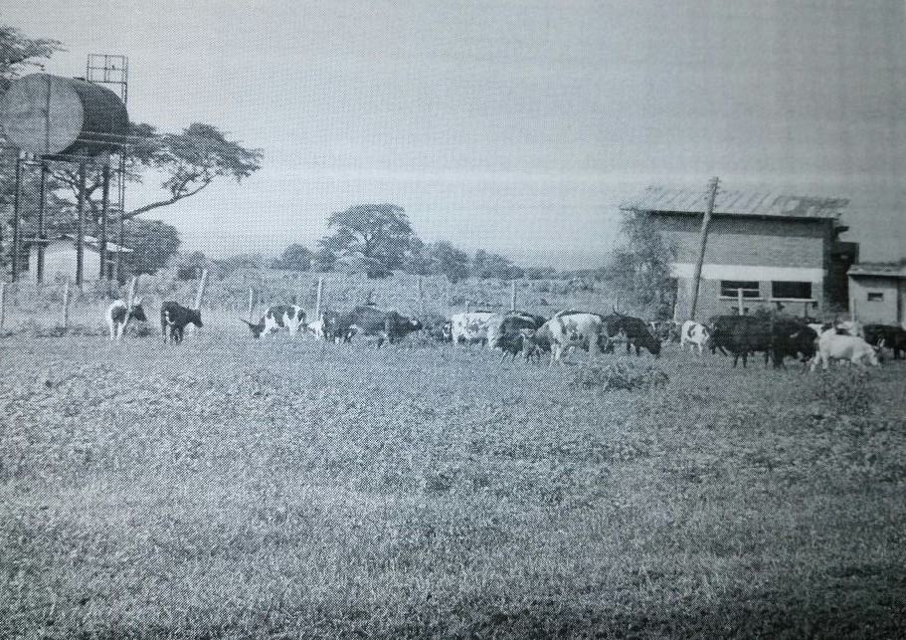

- Giving reason for your answer, state the type of photograph provided above (01 mark)
- Identify the economic activity taking place in the middle ground of the photograph. (01 mark)
- (i)Describe the conditions that have favoured the economic activity identified in (b) above (05 marks)
(ii) Explain the importance of the economic activity to the people living in the area (06 marks)
- Giving reasons for your answer, suggest an area in East Africa where the photograph could have been taken (02 marks)

3. COMPULSORY QUESTION: FIELDWORK (15 MARKS)
Answer all parts of this question
For any one fieldwork study you have conducted either as a group or an individual:
- (i) state the topic of study (01 marks)
(ii) Outline the objectives of the study (02 marks)

- Draw a cross section of the area studied and on it mark and name
- Relief features
- Landuseactivities (05 marks)

- Explain the relationship between relief and landuse activities in the area studied (04 marks)

- Outline the challenges you faced when conducting the fieldwork (03 marks)

SECTION B: EAST AFRICA
Attempt only one Question from this section. Each question carries (20 marks)
4. Study the map of East Africa provided and answer the questions that
follow:
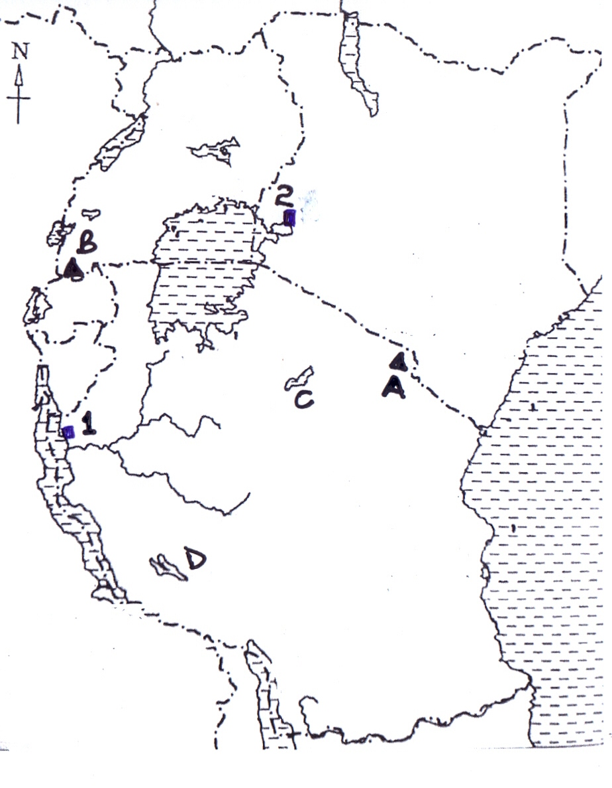
(a) Name the:
(i) Composite cones marked A and B
(ii) Graben Lakes marked C and D
(iii) Ports marked 1 and 2 (06 marks)
(b) Describe the processes which were responsible for the formation of composite cones in East Africa (05 marks)
(c) State the influence of mountains on the climate of East Africa
(05 marks)
(d) Outline the problems faced by the people living in the mountain regions of East Africa (04 marks)
5. Study table 1; below showing Uganda’s total population in millions (1969 - 2014) and answer the questions that follow
Table 1: Uganda’s total population (‘000,000) 1969 – 2014
Year | Population (‘000,000)
1969 | 9.5
1980 | 12.6
1991 | 16.7
2002 | 24.2
2014 | 34.8

Adapted: UBOS; Population census report 2014
- Draw a line graph to represent the information given in the table
(06 mark)

- (i) Calculate the percentage change in Uganda’s population between 1969 and 2014 (02 marks)
(ii) State the factors which have led to the population change in (b) (i) above (04 mark)

- Explain the problems which have resulted from the population change identified in (b) (i) on the physical environment (05 marks)

- Outline the measures being taken to combat the problems of high population growth in East Africa (03 marks)

6. Draw a sketch map of East Africa and on it mark and name:
(a) (i) Rivers:Athi and Pangani (02 marks)
(ii) Towns:Tororo and Dar-es-Salaam (02 marks)
- hydro-electricity power stations:Kindaruma, Hale and Kidatu
(03 marks)
(b) Describe the factors that led to the location of any one hydro-electricity station named in (a) (iii) above (05 marks)
(c) Explain the contributions of the power and energy sector in East Africa (04 marks)
(d) Outline the steps being taken to promote the power and energy sector in East Africa (04 marks)

7. (a) (i) Differentiate between Natural forests and Plantation forests
(02 marks) (ii) Name any two
Planted forests
Natural forests
in Uganda (04 marks)
(b) Describe the conditions that have favoured the establishment of plantation forests in East Africa (04 marks)
(c) Explain the causes of natural forest cover destruction in East Africa (06 marks)
(d)Outline the effects of natural forest cover destruction in East Africa . (04 marks)
END

